SQL Practice: Cultural Fest (well done you have experimented the possible things in it dec 6, 23)  
Planning to create database to practice more ddl, dml commands in sql  
Tables 1. School, 2. Cultural activity, 3.Participants 4. Coach  
  
table column details:

1.school

|  |  |  |  |  |  |
| --- | --- | --- | --- | --- | --- |
| School Code  (primarykey) | School name | address | City | Phone number | Rating (out of 5) |

2.Cultural Activity

|  |  |  |
| --- | --- | --- |
| Serial no (auto increment) | Activity | Category (sports/entertainment) |

3. Student

|  |  |  |  |  |  |
| --- | --- | --- | --- | --- | --- |
| Student_id (primary key) | name | Activity participated | Achievement tab | School code | Coach name |

4. teacher

|  |  |  |  |
| --- | --- | --- | --- |
| Staff id  (Primary key) | Staff name | School code | specialization |

Data for the table:2. CulturalActivity

|  |  |  |
| --- | --- | --- |
| Sno | Activity | Category |
| 1 | Swimming | Sports |
| 2 | Dance | Entertainment |
| 3 | Light music | Entertainment |
| 4 | Foot ball | Sports |
| 5 | Standup Comedy | Entertainment |
| 6 | 100 m Run | Sports |
| 7 | Long jump | Sports |
| 8 | Martial Arts | Sports |
| 9 | Painting | -- |

1.School

|  |  |  |  |  |
| --- | --- | --- | --- | --- |
| School Code | School name | Address | Phone number | Rating |
| HS394 | TMHNU.Mat.Hr.Sec.School | KMC Nagar,Theni | 9943565608 | 3 |
| SS762 | VSJR.Sec.School | Lakshmi Housing Street, Karur | 8344524956 | 5 |
| HS994 | Meenakshi.Govt.Hr.Sec.School | Samudhaya Aram Street, Vellore | 9876768239 | 4 |
| SS834 | KCT.Sec.School | Saravanampatti,Cbe | 7890654312 | 2 |
| SS882 | Kgsil.Public.Sec.School | Keeranatham, Cbe | 6584768323 | -- |
| HS950 | Ruby Mat.Hr.Sec.School | Vikas Avenue, Madurai | 6380464655 | 5 |

3. Student

|  |  |  |  |  |  |
| --- | --- | --- | --- | --- | --- |
| Student Id | name | Activity participated | Achievement tab | School code | Coach name |
| P323 | Tharun | Swimming | yes | HS994 | S282 |
| P112 | Diksh | Dance | Yes | SS762 | S645 |
| P910 | Aravind | 100 m run | No | SS882 | S783 |
| P882 | Aswath | Light music | No | HS394 | S456 |
| P593 | Rukshana | Football | Yes | SS762 | S647 |
| P037 | Prathipa | Standup comedy | Yes | SS762 | S443 |
| P824 | Hari | Martial Arts | Yes | SS882 | S876 |
| P765 | Akila | Painting | Yes | HS394 | S745 |
| P212 | Pavithra | Long jump | No | SS834 | S211 |
| P959 | Sentamil | Dance | No | SS762 | S645 |
| P784 | Sneka | Swimming | Yes | SS882 | S221 |
| P837 | Punitha | Light music | Yes | HS394 | S456 |
| P232 | Mahe | 100 m run | Yes | SS882 | S783 |
| P986 | Thenesha | Dance | No | HS394 | S768 |
| P576 | Gowree | Long jump | Yes | SS834 | S199 |
| P123 | Deva | Martial Arts | Yes | SS882 | S876 |
| P975 | Darshan | Standup Comedy | Yes | SS762 | S443 |
| P505 | Raji | Dance | Yes | HS950 | S556 |
| P936 | Nivetha | Painting | Yes | HS394 | S765 |
| P329 | Reshma | 100 m run | No | SS882 | S873 |
| P942 | Nithya | Painting | Yes | HS394 | S765 |
| P353 | Saranya | Light music | Yes | HS994 | S432 |
| P531 | Iswarya | Swimming | No | HS994 | S221 |
| P249 | Madhumita | Matial Arts | No | SS762 | S700 |
| P930 | Siva | Football | No | HS994 | S543 |
| P747 | Preethi | Painting | Yes | HS394 | S765 |
| P746 | Prabhu | Long jump | Yes | SS762 | S210 |
| P784 | Rama | Swimming | No | HS994 | S282 |
| P463 | Jeevan | Swimming | No | SS882 | S221 |
| P665 | Janani | Light music | No | HS394 | S456 |
| P322 | Dhanan | Foot ball | Yes | SS762 | S647 |
| P345 | Gowsika | Painting | Yes | HS994 | S487 |
| P456 | Koushik | Matrtial Arts | Yes | SS762 | S700 |
| P567 | Vipin | Swimming | No | SS882 | S221 |
| P678 | Karthik | Long jump | Yes | SS834 | S199 |
| P789 | Viveka | Martial Arts | Yes | SS882 | S876 |
| P890 | Sangavi | Swimming | No | HS994 | S282 |
| P901 | Sharanya | Football | No | HS394 | S564 |
| P012 | Nandhini | Swimming | Yes | HS994 | S282 |
| P124 | Jeril | Dance | Yes | SS762 | S645 |
| P236 | Anaka | Swimming | No | SS882 | S221 |
| P765 | Anoosa | Martial Arts | No | SS762 | S700 |
| P339 | Krithika | Dance | Yes | HS950 | S556 |
| P221 | Sabari | Light music | Yes | HS394 | S456 |
| P102 | Praveen | Martial Arts | No | SS762 | S700 |
| P223 | Madhan | Dance | Yes | SS762 | S645 |
| P432 | Vishal | Longjump | No | SS834 | S199 |
| P542 | Priya | Dance | Yes | SS762 | S645 |
| P145 | Soundari | Light music | Yes | HS994 | S432 |
| P204 | Aniruth | Football | No | HS394 | S564 |
| P480 | Gautam | 100 m run | No | HS834 | S777 |
| P472 | Shruthi | Swimming | Yes | SS882 | S221 |
| P247 | Manoj | Dance | Yes | SS762 | S645 |
| P984 | Sangeetha | Long jump | No | SS834 | S199 |
| P138 | Abi | Foot ball | No | HS950 | S198 |
| P398 | Nivetha | Martial Arts | Yes | SS762 | S700 |
| P425 | Palani | Painting | Yes | HS394 | S765 |
| P670 | Daniel | 100 m run | Yes | SS882 | S837 |
| P984 | Joshua | Foot ball | Yes | HS994 | S543 |
| P405 | Steeban | Standup Comedy | No | SS762 | S443 |
| P708 | Charan | Martial arts | Yes | SS882 | S876 |
| P449 | Sadheesh | 100 m run | No | HS834 | S777 |
| P469 | Maianand | Long jump | Yes | SS834 | S211 |
| P296 | Parkavi | Swimming | No | SS882 | S221 |
| P408 | Thenu | Dance | No | HS394 | S768 |
| P545 | Sanju | Swimming | Yes | HS994 | S282 |
| P443 | Varun | 100 m run | Yes | SS882 | S873 |
| P341 | Bhuvi | Standup comedy | yes | SS762 | S443 |

4.TEACHERS

|  |  |  |  |
| --- | --- | --- | --- |
| Staffid | Staffname | SpecialActivity | Schoolcode |
| S221 | Ashok | Swimming | SS882 |
| S432 | Varun | Lightmusic | HS994 |
| S645 | Srimathi | Dance | SS762 |
| S745 | Rohini | Painting | HS394 |
| S765 | Prem | Painting | HS394 |
| S873 | Vishnu | 100m run | SS882 |
| S777 | Biju | 100m run | HS834 |
| S564 | Priyan | Football | HS394 |
| S443 | Pamila | Standup Comedy | SS762 |
| S768 | Anupama | Dance | HS394 |
| S456 | Danasha | Lightmusic | HS394 |
| S876 | Vedha | Martial Arts | SS882 |
| S700 | Anil | Martial Arts | SS762 |
| S487 | Mayail | Painting | HS994 |
| S543 | Bala | Football | HS994 |
| S997 | Chandran | Swimming | HS950 |
| S556 | Nila | Dance | HS950 |
| S199 | Ezhil | Long jump | SS834 |
| S210 | Nimmy | Longjump | SS762 |
| S211 | Farose | Longjump | SS834 |
| S647 | Ganga | Football | SS762 |
| S198 | Vetri | Football | HS950 |
| S282 | Nithesh | Swimming | HS994 |

----  
CREATE TABLE SCHOOL(  
 SCHOOL_CODE INT NOT NULL,  
 SCHOOL_NAME VARCHAR(500),  
 ADDRESS VARCAHR(500),  
 PHONE_NUMBER INT,  
 STARS INT,  
 AGE INT,  
 PRIMARY KEY (SCHOOL_CODE)  
);

DESCRIBE SCHOOL;

ALTER TABLE SCHOOL ADD CITY VARCHAR(100); -- adding column in existing table

ALTER TABLE SCHOOL DROP COLUMN AGE; -- drop the column from existing table

ALTER TABLE SCHOOL RENAME COLUMN STARS TO RATING; --renaming column name

ALTER TABLE SCHOOL MODIFY SCHOOL_CODE VARCHAR(10);

DROP TABLE SCHOOL;

TRUNCATE TABLE SCHOOL;

CREATE TABLE TEACHERS(  
 STAFF_ID INT NOT NULL PRIMARY KEY,  
 STAFF_NAME VARCHAR(50),  
 SPECIAL_ACTIVITY VARCHAR(50),  
 SCHOOL_CODE VARCHAR(10) FOREIGN KEY REFERENCES SCHOOL(SCHOOL_CODE)  
);  
  
CREATE TABLE CULTURAL_ACTIVITY(  
 SERIAL_NO INT AUTO_INCREMENT,  
 ACTIVITY UNIQUE NOT NULL,  
 CATEGORY VARCHAR(20) CHECK(CATEGORY IN (‘ENTERTAINMENT’,’SPORTS’)  
);

CREATE TABLE NEW_STUDENT(  
 STUDENT_ID VARCAHAR(20) PRIMARY KEY,  
 NAME VARCHAR(200),  
 ACTIVITY_PARTICIPATED VARCHAR(200),  
 ACHIEVEMENT_TAB VARCHAR(20),  
 SCHOOL_CODE VARCHAR(10) FOREIGN KEY REFERENCES SCHOOL(SCHOOL_CODE),  
 COACH_ID VARCHAR(10) FOREIDN KEY REFERENCES TEACHERS(STAFF_ID)  
);

--School

INSERT INTO SCHOOL (SCHOOL_CODE,SCHOOL_NAME,ADDRESS,PHONE_NUMBER,RATING)

VALUES('SS762','VSJR.Sec.School','Lakshmi Housing Street, Karur', 8344524956, 5);

INSERT INTO SCHOOL (SCHOOL_CODE, SCHOOL_NAME,ADDRESS,PHONE_NUMBER,RATING)

VALUES('HS994','Meenakshi.Govt.Hr.Sec.School','Samudhaya Aram Street, Vellore',9876768239,4);

INSERT INTO SCHOOL (SCHOOL_CODE,SCHOOL_NAME,ADDRESS,PHONE_NUMBER,RATING)

VALUES('SS834','KCT.Sec.School','Saravanampatti,Cbe',7890654312,2);

INSERT INTO SCHOOL (SCHOOL_CODE,SCHOOL_NAME,ADDRESS,PHONE_NUMBER,RATING)

VALUES('SS882','Kgsil.Public.Sec.School','Keeranatham,Cbe',6584768323,3);

INSERT INTO SCHOOL (SCHOOL_CODE,SCHOOL_NAME,ADDRESS,PHONE_NUMBER,RATING)

VALUES('HS950','Ruby Mat.Hr.Sec.School','Vikas Avenue,Madurai', 6380464655,5)

--Cultural Activity  
INSERT INTO CULTURAL_ACTIVITY(ACTIVITY,CATEGORY)  
VALUES (‘Swimming’,’Sports’);  
INSERT INTO CULTURAL_ACTIVITY(ACTIVITY,CATEGORY)  
VALUES (‘Dance’,’ Entertainment’);  
INSERT INTO CULTURAL_ACTIVITY(ACTIVITY,CATEGORY)  
VALUES (‘Light music’,’ Entertainment’);  
INSERT INTO CULTURAL_ACTIVITY(ACTIVITY,CATEGORY)  
VALUES (‘Football’,’Sports’);  
INSERT INTO CULTURAL_ACTIVITY(ACTIVITY,CATEGORY)  
VALUES (‘Standup Comedy’,’Entertainment’);  
INSERT INTO CULTURAL_ACTIVITY(ACTIVITY,CATEGORY)  
VALUES (‘100m run’,’Sports’);  
INSERT INTO CULTURAL_ACTIVITY(ACTIVITY,CATEGORY)  
VALUES (‘Long Jump’,’Sports’);  
INSERT INTO CULTURAL_ACTIVITY(ACTIVITY,CATEGORY)  
VALUES (‘Martial Arts’,’Sports’);  
INSERT INTO CULTURAL_ACTIVITY(ACTIVITY,CATEGORY)  
VALUES (‘Painting’,’ ’);

--Teacher  
INSERT INTO TEACHERS(STAFF_ID, STAFF_NAME, SPECIAL_ACTIVITY, SCHOOL_CODE)

VALUES('S221','Ashok','Swimming','SS882');

INSERT INTO TEACHERS(STAFF_ID, STAFF_NAME, SPECIAL_ACTIVITY, SCHOOL_CODE)

VALUES('S432','Varun','LightMusic','HS994');

INSERT INTO TEACHERS(STAFF_ID, STAFF_NAME, SPECIAL_ACTIVITY, SCHOOL_CODE)

VALUES('S645','Srimathi','Dance','SS762');

INSERT INTO TEACHERS(STAFF_ID, STAFF_NAME, SPECIAL_ACTIVITY, SCHOOL_CODE)

VALUES('S745','Rohini','Painting','HS394');

INSERT INTO TEACHERS(STAFF_ID, STAFF_NAME, SPECIAL_ACTIVITY, SCHOOL_CODE)

VALUES('S873','Vishnu','100m Run','SS882');

INSERT INTO TEACHERS(STAFF_ID, STAFF_NAME, SPECIAL_ACTIVITY, SCHOOL_CODE)

VALUES('S564','Priyan','Football','HS394');

INSERT INTO TEACHERS(STAFF_ID, STAFF_NAME, SPECIAL_ACTIVITY, SCHOOL_CODE)

VALUES('S443','Pamila','Standup Comedy','SS762');

INSERT INTO TEACHERS(STAFF_ID, STAFF_NAME, SPECIAL_ACTIVITY, SCHOOL_CODE)

VALUES('S768','Anupama','Dance','HS394');

INSERT INTO TEACHERS(STAFF_ID, STAFF_NAME, SPECIAL_ACTIVITY, SCHOOL_CODE)

VALUES('S456','Danasha','LightMusic','HS394');

INSERT INTO TEACHERS(STAFF_ID, STAFF_NAME, SPECIAL_ACTIVITY, SCHOOL_CODE)

VALUES('S876','Vedha','Martial Arts','SS882');

INSERT INTO TEACHERS(STAFF_ID, STAFF_NAME, SPECIAL_ACTIVITY, SCHOOL_CODE)

VALUES('S487','Mayail','Painting','HS994');

INSERT INTO TEACHERS(STAFF_ID, STAFF_NAME, SPECIAL_ACTIVITY, SCHOOL_CODE)

VALUES('S997','Chandran','Swimming','HS950');

INSERT INTO TEACHERS(STAFF_ID, STAFF_NAME, SPECIAL_ACTIVITY, SCHOOL_CODE)

VALUES('S543','Bala','Football','HS994');

INSERT INTO TEACHERS(STAFF_ID, STAFF_NAME, SPECIAL_ACTIVITY, SCHOOL_CODE)

VALUES('S199','Ezhil','Long Jump','SS834');

INSERT INTO TEACHERS(STAFF_ID, STAFF_NAME, SPECIAL_ACTIVITY, SCHOOL_CODE)

VALUES('S211','Farose','Long Jump','SS834');

INSERT INTO TEACHERS(STAFF_ID, STAFF_NAME, SPECIAL_ACTIVITY, SCHOOL_CODE)

VALUES('S647','Ganga','Football','SS762');

INSERT INTO TEACHERS(STAFF_ID, STAFF_NAME, SPECIAL_ACTIVITY, SCHOOL_CODE)

VALUES('S282','Nithesh','Swimming','HS994');  
INSERT INTO TEACHERS(STAFF_ID, STAFF_NAME, SPECIAL_ACTIVITY, SCHOOL_CODE)

VALUES('S765','Prem','Painting','HS394');

INSERT INTO TEACHERS(STAFF_ID, STAFF_NAME, SPECIAL_ACTIVITY, SCHOOL_CODE)

VALUES('S777','Biju','100m run','HS394');

INSERT INTO TEACHERS(STAFF_ID, STAFF_NAME, SPECIAL_ACTIVITY, SCHOOL_CODE)

VALUES('S700','Anil','Martial Arts','SS762');

INSERT INTO TEACHERS(STAFF_ID, STAFF_NAME, SPECIAL_ACTIVITY, SCHOOL_CODE)

VALUES('S556','Nila','Dance','HS950');

INSERT INTO TEACHERS(STAFF_ID, STAFF_NAME, SPECIAL_ACTIVITY, SCHOOL_CODE)

VALUES('S198','Vetri','Football','HS950');  
-----------------------------------------------------------------------------------

--New_student  
INSERT INTO NEW_STUDENT

(STUDENT_ID,NAME,ACTIVITY_PARTICIPATED,ACHIEVEMENT_TAB,SCHOOL_CODE,COACH_ID)

VALUES('P323','Tharun','Swimming','Yes','HS994','S282');

INSERT INTO NEW_STUDENT

(STUDENT_ID,NAME,ACTIVITY_PARTICIPATED,ACHIEVEMENT_TAB,SCHOOL_CODE,COACH_ID)

VALUES('P182','Diksh','Dance','Yes','SS762','S645');

INSERT INTO NEW_STUDENT

(STUDENT_ID,NAME,ACTIVITY_PARTICIPATED,ACHIEVEMENT_TAB,SCHOOL_CODE,COACH_ID)

VALUES('P882','Aswath','Light music','No','HS394','S456');

INSERT INTO NEW_STUDENT

(STUDENT_ID,NAME,ACTIVITY_PARTICIPATED,ACHIEVEMENT_TAB,SCHOOL_CODE,COACH_ID)

VALUES('P593','Rukshana','Football','Yes','SS762','S647');

INSERT INTO NEW_STUDENT

(STUDENT_ID,NAME,ACTIVITY_PARTICIPATED,ACHIEVEMENT_TAB,SCHOOL_CODE,COACH_ID)

VALUES('P910','Aravind','100m run','No','SS882','S873');  
INSERT INTO NEW_STUDENT

(STUDENT_ID,NAME,ACTIVITY_PARTICIPATED,ACHIEVEMENT_TAB,SCHOOL_CODE,COACH_ID)

VALUES('P583','Prathipa','Standup Comedy','Yes','SS762','S647');

INSERT INTO NEW_STUDENT

(STUDENT_ID,NAME,ACTIVITY_PARTICIPATED,ACHIEVEMENT_TAB,SCHOOL_CODE,COACH_ID)

VALUES('P824','Hari','Martial Arts','Yes','SS882','S876');

INSERT INTO NEW_STUDENT

(STUDENT_ID,NAME,ACTIVITY_PARTICIPATED,ACHIEVEMENT_TAB,SCHOOL_CODE,COACH_ID)

VALUES('P765','Akila','Painting','Yes','HS394','S745');

INSERT INTO NEW_STUDENT

(STUDENT_ID,NAME,ACTIVITY_PARTICIPATED,ACHIEVEMENT_TAB,SCHOOL_CODE,COACH_ID)

VALUES('P212','Pavithra','Long jump','No','SS834','S211');

INSERT INTO NEW_STUDENT

(STUDENT_ID,NAME,ACTIVITY_PARTICIPATED,ACHIEVEMENT_TAB,SCHOOL_CODE,COACH_ID)

VALUES('P959','Sentamil','Dance','No','SS762','S645');

INSERT INTO NEW_STUDENT

(STUDENT_ID,NAME,ACTIVITY_PARTICIPATED,ACHIEVEMENT_TAB,SCHOOL_CODE,COACH_ID)

VALUES('P784','Sneka','Swimming','Yes','SS882','S221');

INSERT INTO NEW_STUDENT

(STUDENT_ID,NAME,ACTIVITY_PARTICIPATED,ACHIEVEMENT_TAB,SCHOOL_CODE,COACH_ID)

VALUES('P837','Punitha','Light music','Yes','HS394','S456')

INSERT INTO NEW_STUDENT

(STUDENT_ID,NAME,ACTIVITY_PARTICIPATED,ACHIEVEMENT_TAB,SCHOOL_CODE,COACH_ID)

VALUES('P232','Mahe','100m run','Yes','SS882','S221')

INSERT INTO NEW_STUDENT

(STUDENT_ID,NAME,ACTIVITY_PARTICIPATED,ACHIEVEMENT_TAB,SCHOOL_CODE,COACH_ID)

VALUES('P986','Thenesha','Dance','Yes','HS394','S768')

INSERT INTO NEW_STUDENT

(STUDENT_ID,NAME,ACTIVITY_PARTICIPATED,ACHIEVEMENT_TAB,SCHOOL_CODE,COACH_ID)

VALUES('P576','Gowree','Long jump','Yes','SS882','S221')

INSERT INTO NEW_STUDENT

(STUDENT_ID,NAME,ACTIVITY_PARTICIPATED,ACHIEVEMENT_TAB,SCHOOL_CODE,COACH_ID)

VALUES('P123','Deva','Martial Arts','Yes','SS882','S876');

INSERT INTO NEW_STUDENT

(STUDENT_ID,NAME,ACTIVITY_PARTICIPATED,ACHIEVEMENT_TAB,SCHOOL_CODE,COACH_ID)

VALUES('P975','Darshan','Standup Comedy','Yes','SS762','S443');

INSERT INTO NEW_STUDENT

(STUDENT_ID,NAME,ACTIVITY_PARTICIPATED,ACHIEVEMENT_TAB,SCHOOL_CODE,COACH_ID)

VALUES('P505','Raji','Dance','Yes','HS950','S556');

INSERT INTO NEW_STUDENT

(STUDENT_ID,NAME,ACTIVITY_PARTICIPATED,ACHIEVEMENT_TAB,SCHOOL_CODE,COACH_ID)

VALUES('P936','Nivetha','Painting','Yes','HS394','S765')

INSERT INTO NEW_STUDENT

(STUDENT_ID,NAME,ACTIVITY_PARTICIPATED,ACHIEVEMENT_TAB,SCHOOL_CODE,COACH_ID)

VALUES('P329','Reshma','100m run','No','SS882','S873')

INSERT INTO NEW_STUDENT  
(STUDENT_ID,NAME,ACTIVITY_PARTICIPATED,ACHIEVEMENT_TAB,SCHOOL_CODE,COACH_ID)  
VALUES(‘P765’,’Anoosa’,’Martial Arts’,’No’,’SS762’,’S700’)  
INSERT INTO NEW_STUDENT  
(STUDENT_ID,NAME,ACTIVITY_PARTICIPATED,ACHIEVEMENT_TAB,SCHOOL_CODE,COACH_ID)  
VALUES(‘P339’,’Krithika’,’Dance’,’Yes’,’HS950’,’S556’)  
INSERT INTO NEW_STUDENT  
(STUDENT_ID,NAME,ACTIVITY_PARTICIPATED,ACHIEVEMENT_TAB,SCHOOL_CODE,COACH_ID)  
VALUES(‘P221’,’Sabari’,’Light music’,’Yes’,’HS394’,’S456’)  
INSERT INTO NEW_STUDENT  
(STUDENT_ID,NAME,ACTIVITY_PARTICIPATED,ACHIEVEMENT_TAB,SCHOOL_CODE,COACH_ID)  
VALUES(‘P102’,’Praveen’,’Martial Arts’,’No’,’SS762’,’S700’)  
INSERT INTO NEW_STUDENT  
(STUDENT_ID,NAME,ACTIVITY_PARTICIPATED,ACHIEVEMENT_TAB,SCHOOL_CODE,COACH_ID)  
VALUES(‘P223’,’Madhan’,’Dance’,’Yes’,’SS762’,’S645’)  
INSERT INTO NEW_STUDENT  
(STUDENT_ID,NAME,ACTIVITY_PARTICIPATED,ACHIEVEMENT_TAB,SCHOOL_CODE,COACH_ID)  
VALUES(‘P432’,’Vishal’,’LongJump’,’No’,’SS834’,’S199’)  
INSERT INTO NEW_STUDENT  
(STUDENT_ID,NAME,ACTIVITY_PARTICIPATED,ACHIEVEMENT_TAB,SCHOOL_CODE,COACH_ID)  
VALUES(‘P542’,’Priya’,’Dance’,’Yes’,’SS762’,’S645’)  
INSERT INTO NEW_STUDENT  
(STUDENT_ID,NAME,ACTIVITY_PARTICIPATED,ACHIEVEMENT_TAB,SCHOOL_CODE,COACH_ID)  
VALUES(‘P145’,’Soundari’,’Light music’,’Yes’,’HS994’,’S432’)  
  
INSERT INTO NEW_STUDENT  
(STUDENT_ID,NAME,ACTIVITY_PARTICIPATED,ACHIEVEMENT_TAB,SCHOOL_CODE,COACH_ID)  
VALUES(‘P204’,’Aniruth’,’Football’,’No’,’HS394’,’S564’)  
INSERT INTO NEW_STUDENT  
(STUDENT_ID,NAME,ACTIVITY_PARTICIPATED,ACHIEVEMENT_TAB,SCHOOL_CODE,COACH_ID)  
VALUES(‘P480’,’Gautam’,’100m run’,’No’,’HS834’,’S777’)  
INSERT INTO NEW_STUDENT  
(STUDENT_ID,NAME,ACTIVITY_PARTICIPATED,ACHIEVEMENT_TAB,SCHOOL_CODE,COACH_ID)  
VALUES(‘P472’,’Shruthi’,’Swimming’,’Yes’,’SS882’,’S221’)  
INSERT INTO NEW_STUDENT  
(STUDENT_ID,NAME,ACTIVITY_PARTICIPATED,ACHIEVEMENT_TAB,SCHOOL_CODE,COACH_ID)  
VALUES(‘P247’,’Manoj’,’Dance’,’Yes’,’SS762’,’S645’)  
INSERT INTO NEW_STUDENT  
(STUDENT_ID,NAME,ACTIVITY_PARTICIPATED,ACHIEVEMENT_TAB,SCHOOL_CODE,COACH_ID)  
VALUES(‘P984’,’Sangeetha’,’Longjump’,’No’,’SS834’,’S199’)

INSERT INTO NEW_STUDENT

(STUDENT_ID,NAME,ACTIVITY_PARTICIPATED,ACHIEVEMENT_TAB,SCHOOL_CODE,COACH_ID)

VALUES('P138','Abi','Football','No','HS950','S198')

INSERT INTO NEW_STUDENT

(STUDENT_ID,NAME,ACTIVITY_PARTICIPATED,ACHIEVEMENT_TAB,SCHOOL_CODE,COACH_ID)

VALUES('P398','Nivetha','Martial Arts','Yes','SS762','S700')

INSERT INTO NEW_STUDENT

(STUDENT_ID,NAME,ACTIVITY_PARTICIPATED,ACHIEVEMENT_TAB,SCHOOL_CODE,COACH_ID)

VALUES('P425','Palani','Painting','Yes','HS394','S765')

INSERT INTO NEW_STUDENT

(STUDENT_ID,NAME,ACTIVITY_PARTICIPATED,ACHIEVEMENT_TAB,SCHOOL_CODE,COACH_ID)

VALUES('P670','Daniel','100m run','Yes','SS882','S873')

INSERT INTO NEW_STUDENT

(STUDENT_ID,NAME,ACTIVITY_PARTICIPATED,ACHIEVEMENT_TAB,SCHOOL_CODE,COACH_ID)

VALUES('P984','Joshua','Foot ball','Yes','HS994','S543')

INSERT INTO NEW_STUDENT

(STUDENT_ID,NAME,ACTIVITY_PARTICIPATED,ACHIEVEMENT_TAB,SCHOOL_CODE,COACH_ID)

VALUES('P405','Steeban','Standup Comedy','No','SS762','S443')  
INSERT INTO NEW_STUDENT

(STUDENT_ID,NAME,ACTIVITY_PARTICIPATED,ACHIEVEMENT_TAB,SCHOOL_CODE,COACH_ID)

VALUES('P469','Maianand','Longjump','Yes','SS834','S211')

INSERT INTO NEW_STUDENT

(STUDENT_ID,NAME,ACTIVITY_PARTICIPATED,ACHIEVEMENT_TAB,SCHOOL_CODE,COACH_ID)

VALUES('P296','Parkavi','Swimming','No','SS882','S221')

INSERT INTO NEW_STUDENT

(STUDENT_ID,NAME,ACTIVITY_PARTICIPATED,ACHIEVEMENT_TAB,SCHOOL_CODE,COACH_ID)

VALUES('P408','Thenu','Dance','No','HS394','S768')

INSERT INTO NEW_STUDENT

(STUDENT_ID,NAME,ACTIVITY_PARTICIPATED,ACHIEVEMENT_TAB,SCHOOL_CODE,COACH_ID)

VALUES('P545','Sanju','Swimming','Yes','HS994','S282')

INSERT INTO NEW_STUDENT

(STUDENT_ID,NAME,ACTIVITY_PARTICIPATED,ACHIEVEMENT_TAB,SCHOOL_CODE,COACH_ID)

VALUES('P443','Varun','100m run','Yes','SS882','S873')

INSERT INTO NEW_STUDENT

(STUDENT_ID,NAME,ACTIVITY_PARTICIPATED,ACHIEVEMENT_TAB,SCHOOL_CODE,COACH_ID)

VALUES('P341','Bhuvi','Standup Comedy','Yes','SS762','S443')

----------CODE IS WORKING---------  
1) 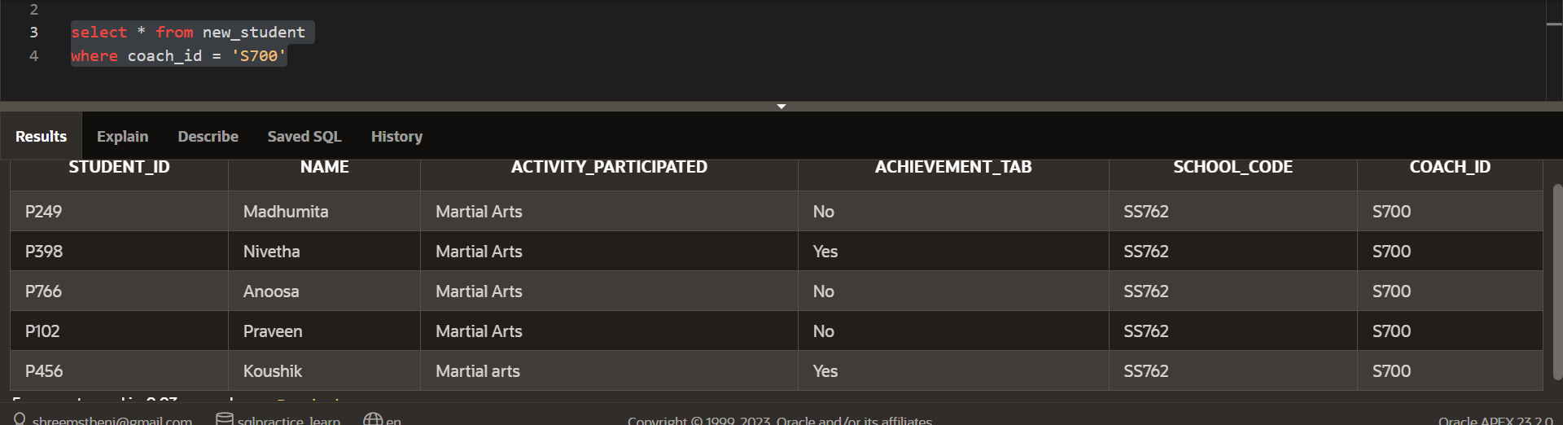

2) 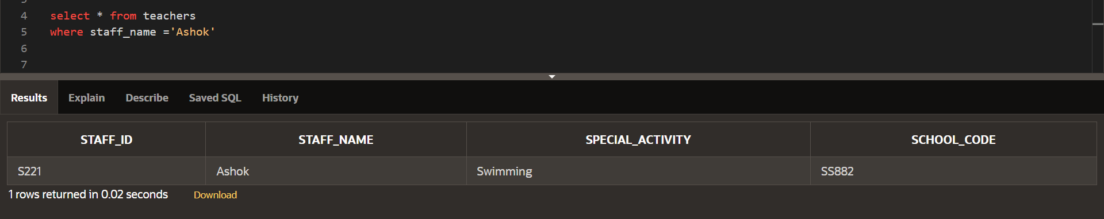

3)   
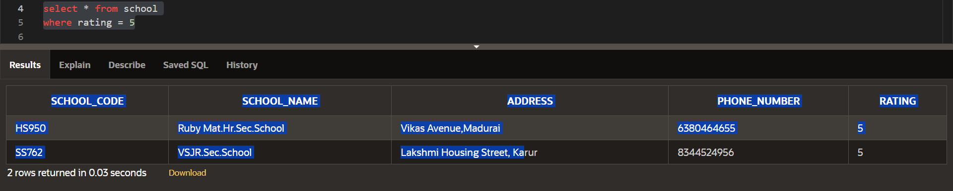

4) 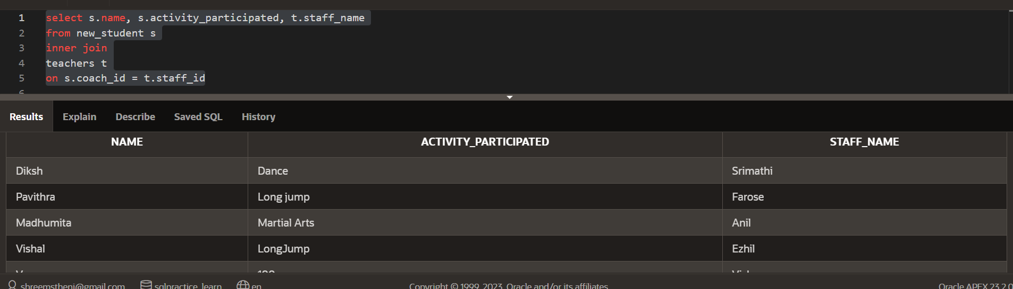

6)

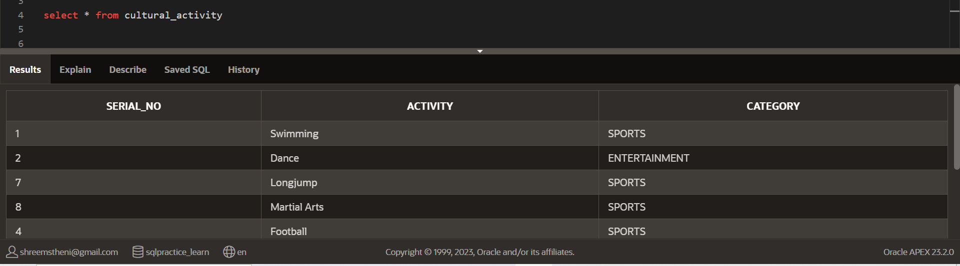

7) 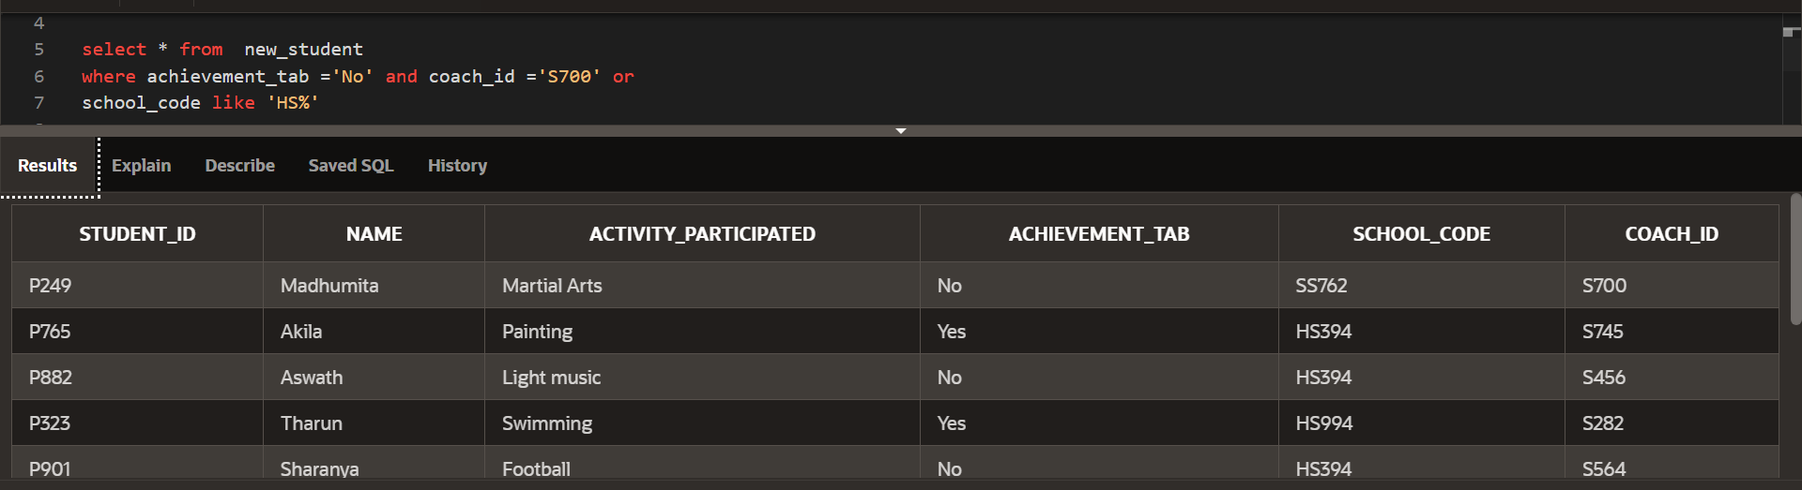

8) 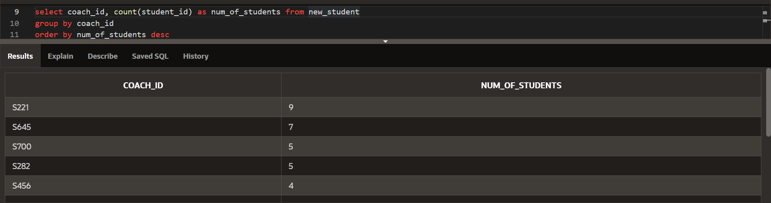

9) 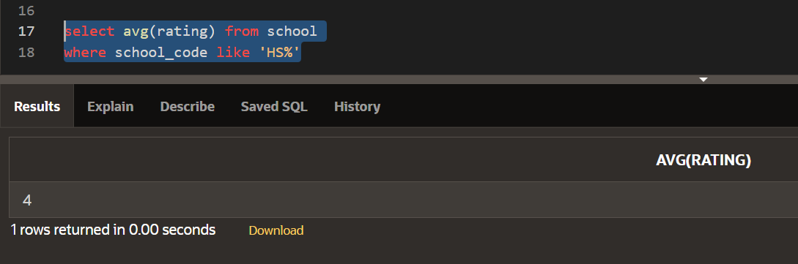

10) 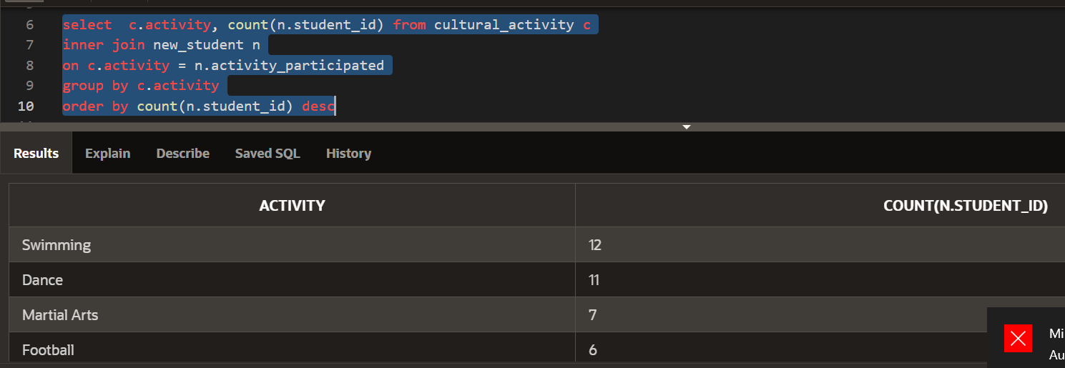

11) 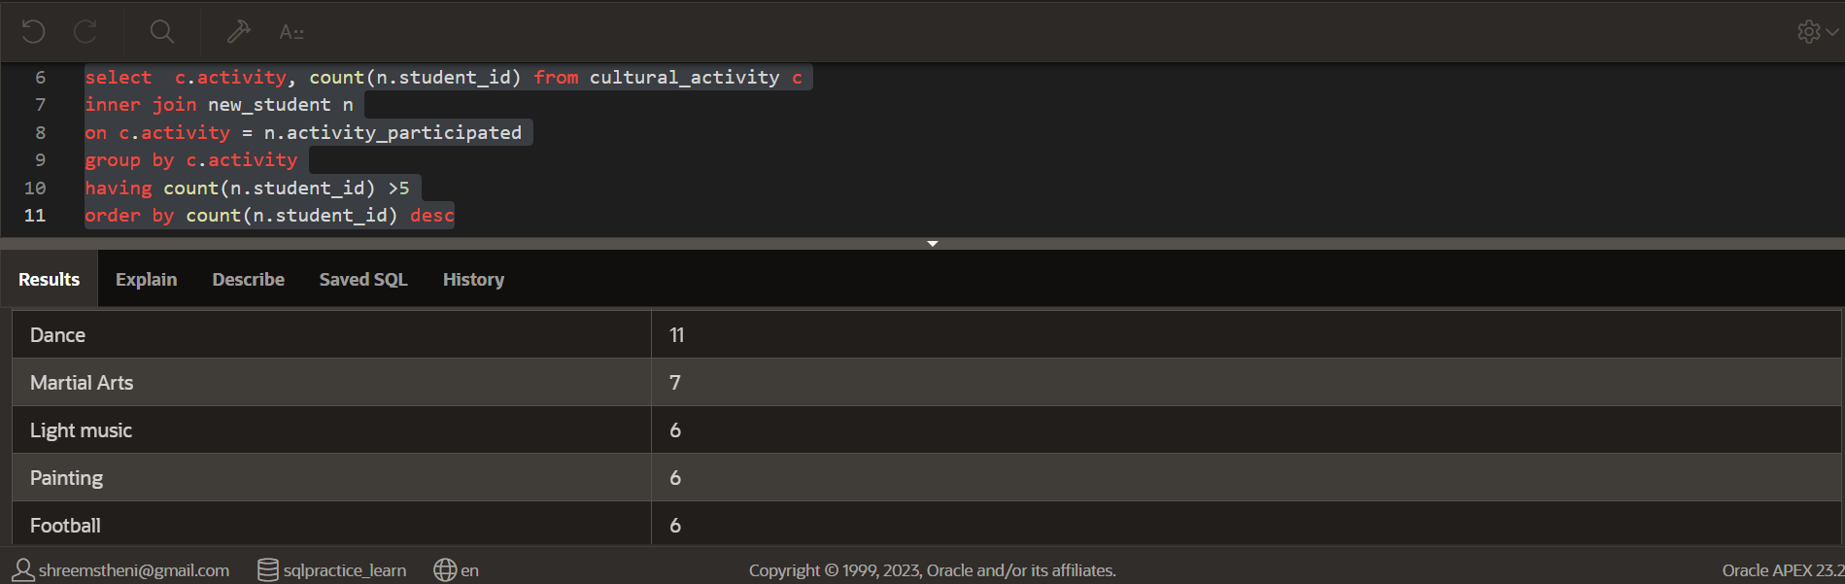

12) 

